UBER RIDES BOOKINGS
DELHI NCR ── PERFORMANCE ANALYSIS

SUMMERY
This report looks at 150,000 Uber ride bookings from Delhi NCR, digging into what actually happens on the platform — how many rides get completed, why others get cancelled or left incomplete, how much revenue is generated, how people pay, and how satisfied customers and drivers are.
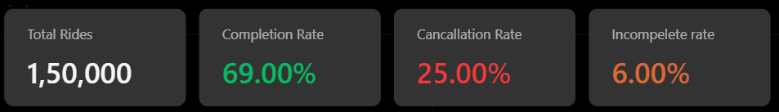
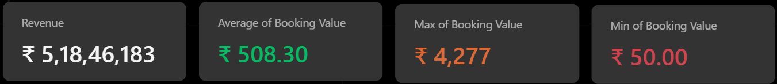
Key Findings
• The Total number of Rides Booked are 1,50,000 , While the Total rides are 1,50,000 only 69% of ride requests are completed. A full quarter of all booking (25%, 37,500 rides) end in cancellation and (6% , 9,000 rides) of rides requested are Incomplete.
• Drivers are responsible for 2.5× more ride cancellations than customers (27,000 vs 10,500 All rides).
• The average booking value per ride is ₹508.30. The highest booking value recorded is ₹4,277 while the lowest booking value is ₹50.
• Incomplete rides (6%, 9,000 trips) are driven almost equally by customer demand, vehicle breakdown, and other issues.
• UPI is the most used payment method, contributing 45% of the total revenue (₹5,18,46,183). Cash (25%) and Uber Wallet (12%) rank second and third.

1. Ride Volume & Outcomes
Out of 150,000 total ride requests, 103,500 (69.0%) were completed successfully. The remaining 31% split between cancellations (25.0%) and incomplete rides (6.0%) — meaning roughly 1 in 3 ride requests never results in a paid, finished trip.

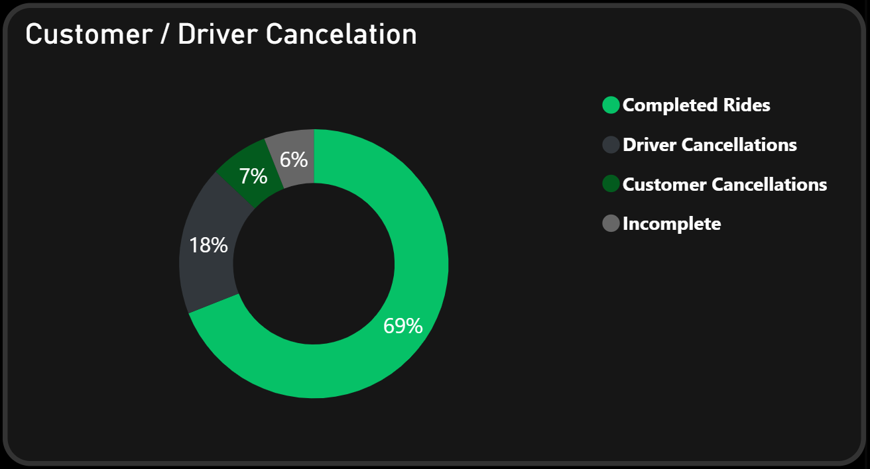es
Out of all rides, 18.0% were cancelled by drivers and 7.0% were cancelled by customers. Driver-side cancellations are 2.5× higher than customer-side cancellations, indicating that the major cancellation issue comes from the driver side.

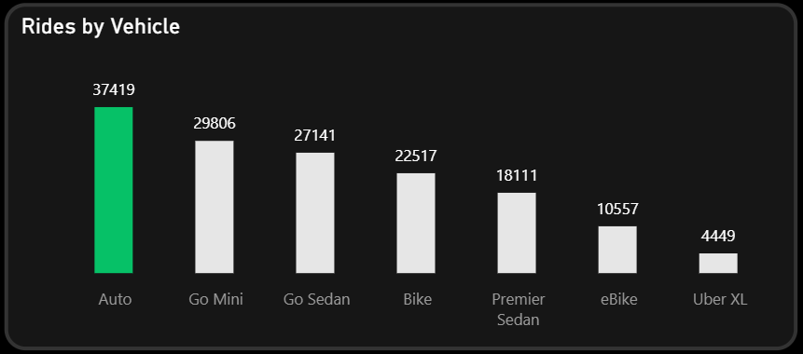
• Auto is the most booked vehicle type with 37,419 rides, showing the highest customer demand.
• Go Mini (29,806) and Go Sedan (27,141) are the second and third most booked vehicle types.
• The top three vehicle types (Auto, Go Mini, and Go Sedan) account for the majority of total bookings. ─(94,366 Total rides)
• Uber XL has the lowest number of bookings (4,449), suggesting limited customer demand for larger vehicles.
• the bookings keep falling Downward , suggesting people prefer affordable mode of transport over premium Vehicle.
Vehicle Type | Rides | Revenue (₹) | AVG Booking Value
Auto | 37419 | 1,28,78,422 | 506
Go Mini | 22517 | 1,03,38,496 | 507
Go Sedan | 10557 | 93,69,719 | 511
Bike | 29806 | 78,37,697 | 510
Premier Sedan | 27141 | 62,75,332 | 509
ebike | 18111 | 36,18,485 | 503
Uber XL | 4449 | 15,28,032 | 502

2. Cancellation Analysis
37,500 rides were cancelled in total: 27,000 by drivers and 10,500 by customers. Cancellation volume scales with ride volume across vehicle types — Auto and Go Mini see the highest absolute cancellations simply because they carry the most bookings — but the driver-to-customer cancellation ratio is consistently skewed toward drivers across every vehicle type.

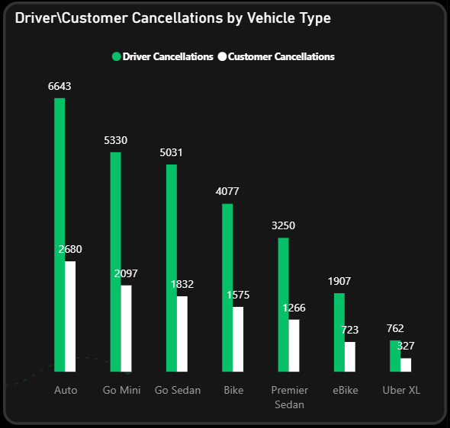
Customer cancellations are distributed fairly evenly across the top four reasons, each contributing around 22% of total customer cancellations. "Wrong Address" (2,362) is the leading reason, closely followed by "Change of Plans" (2,353), "Driver is not moving towards the pickup location" (2,335), and "Driver asked to cancel" (2,295). "AC is not working" (1,155) accounts for the remaining 11%. While the first two reasons are mostly customer-driven, the latter two highlight operational issues that can be reduced through better driver management.

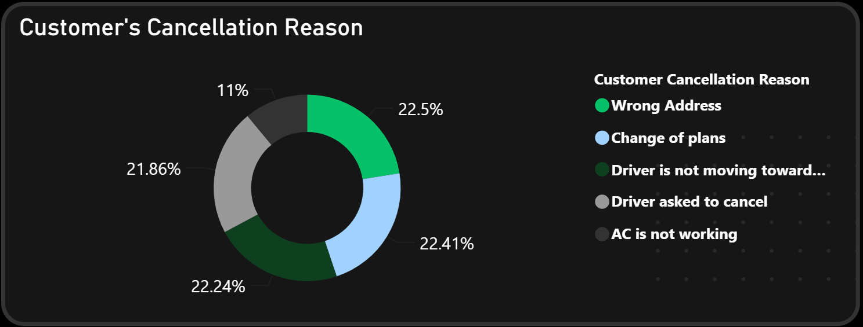

On the driver side, the four reasons are almost evenly distributed (~25% each): customer-related issues, customer illness/coughing, personal/car-related issues, and overcrowding (more passengers than permitted). Unlike the customer-side reasons, three of these four are directly tied to driver experience and vehicle-suitability at pickup — pointing to a mismatch between what's booked and what's encountered.

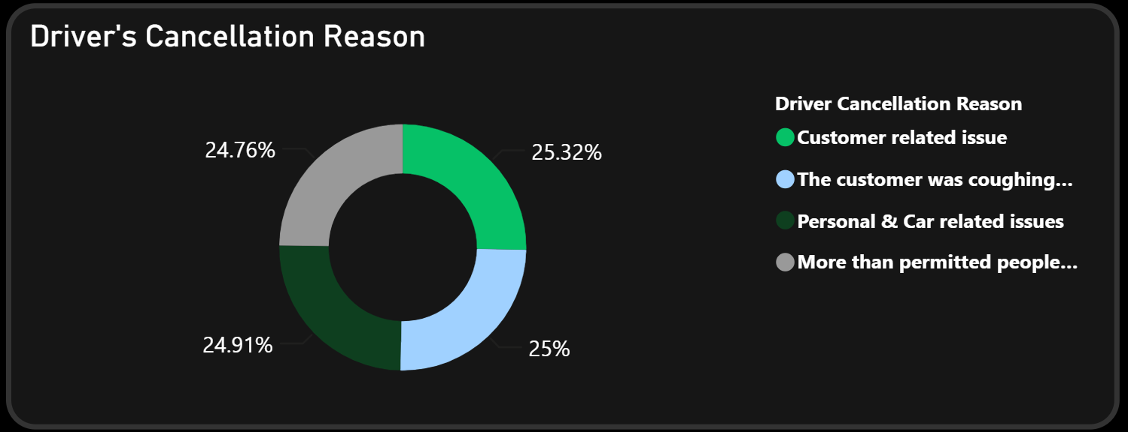

3. Incomplete Rides
9,000 rides (6.0% of total volume) started but were never completed — a distinct failure mode from cancellation, since the driver has already been dispatched and, in some cases, the trip may already be underway. This carries a higher cost than a cancellation: wasted driver time, partial trip risk, and a worse customer experience.

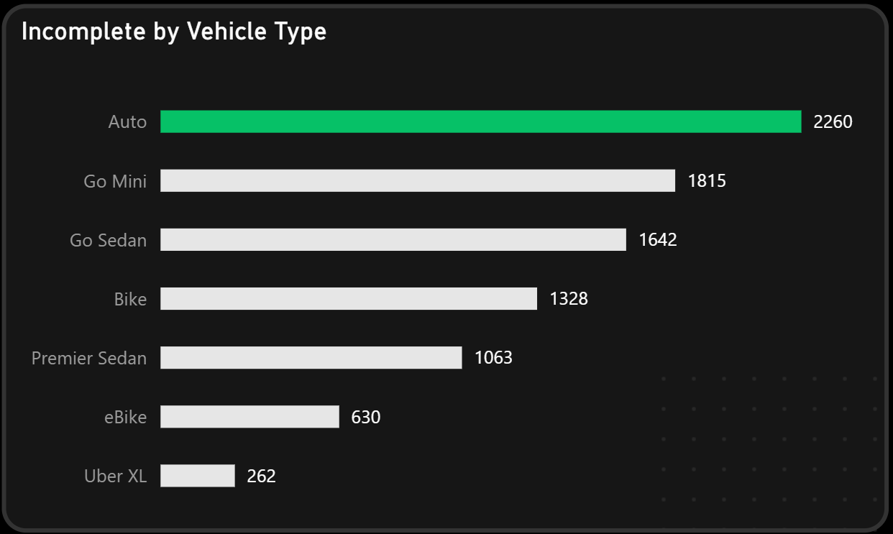

The three reasons for incomplete rides are close to evenly split: customer demand (33.8%), vehicle breakdown (33.5%), and other/unclassified issues (32.8%). The near-equal split across a demand-side reason and a supply-side
Both side of cancellation cause demand different method and approach.
Need of more Efficient and Clear records for Other issues to manage and provide better support to resolve them.

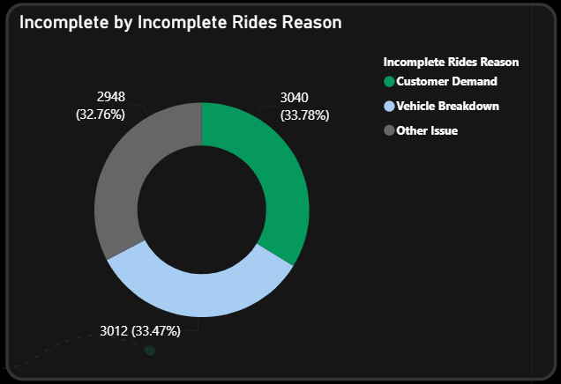

4. Revenue & Payment Behavior
The platform generated a total revenue of ₹51,846,183 from 103,500 completed rides. The average booking value stands at ₹508.30, indicating a healthy revenue per trip. Booking values range from a minimum of ₹50 to a maximum of ₹4,277, reflecting a wide variety of ride types and trip distances.

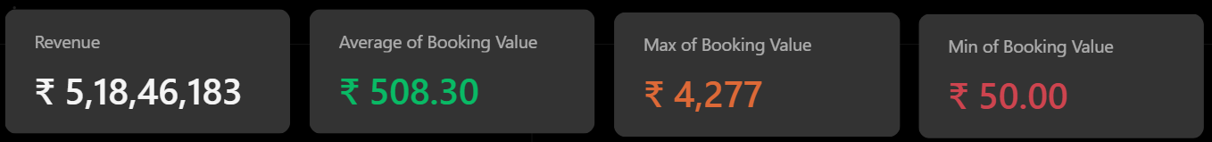
More than 50% of the platform's total revenue (₹32,586,637) comes from Auto, Go Mini, and Go Sedan, making them the key contributors to overall earnings.

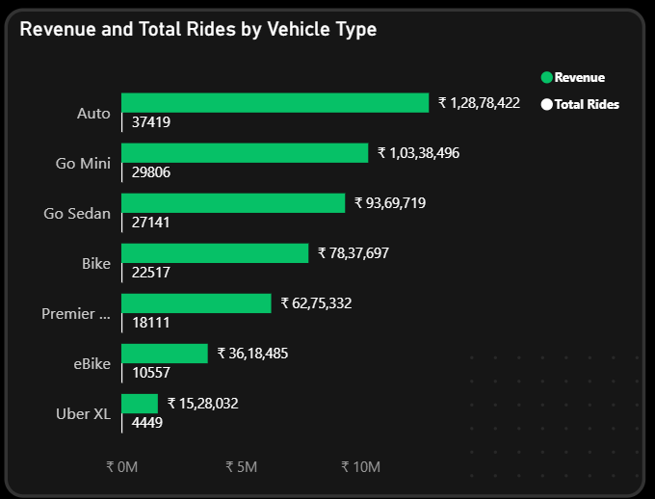

Vehicle Type | Rides | Revenue | Business Insight
Auto | 37,419 | ₹1.29 Cr | Top-performing vehicle type
Go Mini | 29,806 | ₹1.03 Cr | Second-largest contributor to revenue
Go Sedan | 27,141 | ₹93.70 Lakh | One of the platform's strong performers
Bike | 22,517 | ₹78.38 Lakh | Popular choice for daily travel
Premier Sedan | 18,111 | ₹62.75 Lakh | Provides steady revenue
eBike | 10,557 | ₹36.18 Lakh | Mainly used for short-distance trips
Uber XL | 4,449 | ₹15.28 Lakh | Lowest demand among all vehicle types

The payment method distribution is consistent across all vehicle categories, indicating stable customer payment behavior. UPI leads with 45% of transactions, Cash accounts for 25%, and Credit Card, Debit Card, and Uber Wallet together make up the remaining 30%.

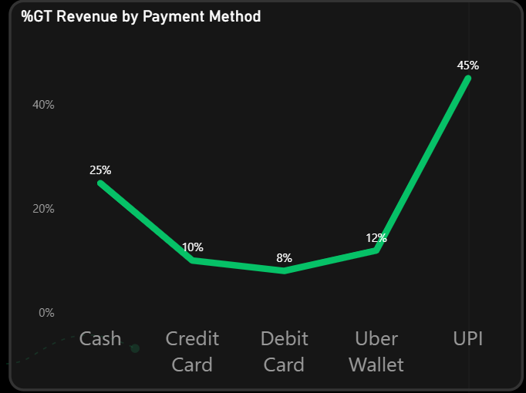

While every payment method stays consistent on average of ₹508 , Credit Card users have the highest average booking value (₹511.71) , while Uber Wallet has the lowest average booking value (₹505.12). This suggests Credit Cards are preferred for higher-value rides, whereas Uber Wallet is mainly used for lower-value bookings.

5. Service Quality Signals
Average customer rating (4.40/5) is meaningfully higher than average driver rating (4.23/5),
• Both ratings stay in a narrow, high range (4.0–4.8) — very few bad ratings on either side.
• The takeaway: Once a ride actually happens, the experience is good for everyone. So ratings aren't the problem — the real issue is getting rides completed in the first place, not how people feel afterward.

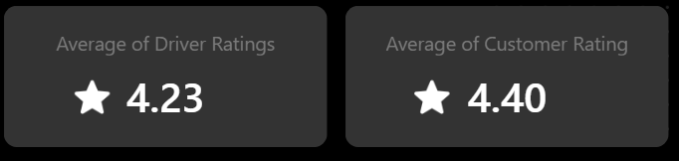
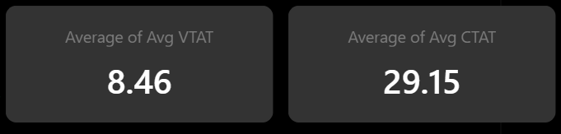

Average Vehicle Turnaround Time (VTAT — time from booking to driver pickup) is 8.46 minutes, with Average Customer Turnaround Time (CTAT — total trip time) at 29.15 minutes. VTAT has a broad spread (2–20 minutes), meaning pickup-time reliability is inconsistent — a possible contributor to both cancellation and incomplete-ride rates.

6.Recommendation

• Fix driver cancellations first: 18% of all bookings are cancelled by drivers — the biggest reason rides don't happen. Drivers not heading to pickup or asking to cancel are things the company can fix through better matching/dispatch.
• Make pickup wait times more consistent: It's not just about the average wait time — it's about avoiding really long waits too. Making wait times more predictable will likely reduce both cancellations and incomplete rides.
• Look into vehicle breakdowns separately: 33.5% of incomplete rides happen because of vehicle breakdowns. This isn't a driver problem — it's a sign that vehicles aren't being checked or maintained properly before they go on the road.
• Keep pushing UPI as the main payment method: UPI already makes up 44% of payments. Instead of adding more payment options, focus on making UPI even smoother and consider rewards to keep people using it.
• Promote Uber Wallet more actively: Right now, wallet usage is low compared to other payment methods. The company should introduce cashback, wallet-only discounts, or auto top-ups to encourage more people to use it — this also reduces reliance on outside payment gateways.

